**EXPERIMENT 11:(PROCEDURES)**

**AIM:**

* Create a table with attributes students and marks.
* Insert values into the table.
* Create a procedure to get the merit students (marks > 50).
* Create a procedure to get marks of a given id (using in).
* Create a procedure to display highest marks (using out).
* Create a procedure to get marks of a given id (using in and out).

**SOLUTION:**

**Components:**

Procedures: Database Procedures (sometimes referred to as Stored Procedures or Procs) are subroutines that can contain one or more SQL statements that perform a specific task. They can be used for data validation, access control, or to reduce network traffic between clients and the DBMS servers.

CODE:

Create table proc (id int,marks int);

Insert into proc values (1, 30),(2, 40), (3,50), (5, 60), (6, 70);

select * from proc;

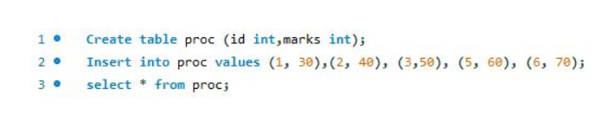

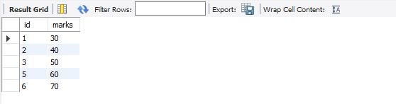

delimiter //

create procedure get_merit_student()

begin

select * from proc where marks > 50;

end //

delimiter ;

call get_merit_student();

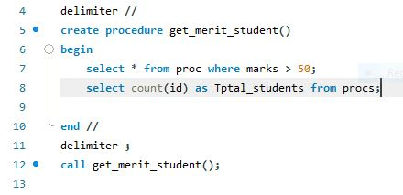

OUTPUT:

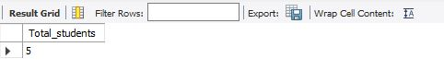

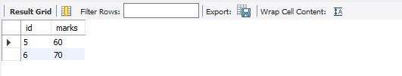

delimiter //

create procedure get_marks(IN stdid int)

begin

select marks from proc where (id = stdid);

end //

delimiter ;

call get_marks(3);

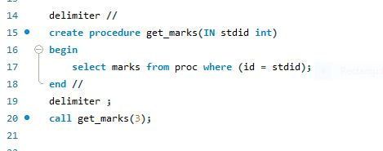

OUTPUT:

